This problem will be worth 16 points. Each successfully implemented function will earn you a point. There is the one student tester and one test for each of the 10 functions for a total of 11 tests. Additional bonus points will be awarded for correctly implementing methods 1-3, methods 4 - 6, methods 7and 8, methods 9 and 10 and a final bonus point for correctly implementing all 10 methods in this class.

This problem will ask you to implement the following functions. One function is defined recursively. Other times I will give you functions from the java.lang.Math with a brief description, and some times you just need to implement the function. In all the following functions you do NOT need worry about domain issues. That is, you may assume that all test data will not cause any exceptions to be thrown. In total, there are ten different functions in this problem. All methods which return a double must return value within 0.05 of the correct answer to be considered correct.

You should use:
- Math.max(a,b) for max{a, b}. | - Math.min(a, b) for min(a, b)
- Math.abs(x) for |x|. | - Math.cos(a) for cos(a)
- Math.sqrt(x) for 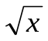 | - Math.sin(a) for sin(a)
- Math.pow(x, 1.0/n) for 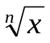 | - Math.tan(a) for tan(a)
- Math.log(a) for 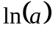 | - Math.log10(a) for 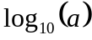 or 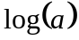
- Math.ceil(a) for 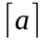. | - Math.floor(a) for 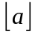.

note:
- Return type of Math.abs, Math.max and Math.min is the same as its argument(s).
- Return type of all other methods is double.
- 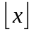 is the largest (Closes to positive infinity) double value smaller than or equal to x. For example, 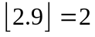 and 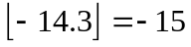.
- 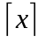 is the smallest (Closes to negative infinity) double value that is greater than or equal to x. For example, 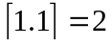 and 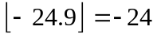.
- Use the following constant for pi (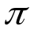)
Math.PI | The double value that is closer than any other to pi, the ratio of the circumference of a circle to its diameter.
- Use the following constant for 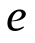
Math.E | The double value that is closer than any other to e, the base of the natural logarithms.

- Implement the following integer recursive function. All calculations shall be computed using Integer
math.
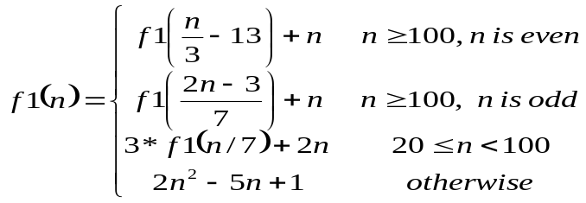
using the following function heading:
public static int f1(int n)

Test data: f1(5) returns 26

The correct call to a recursive static method is of the form: FunctionsGoneWild2015.f1(n)

- Implement the following function.
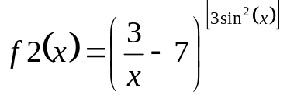
Use the following function heading:
public static double f2(double x)

Test data: f2(11) returns 45.2562

The correct call to the static method is of the form: FunctionsGoneWild2015.f2(x)

- Implement the following function
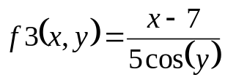

Use following function heading:

public static double f3(double x, double y)

Test data: f3(1.5, 1.9) returns 3.4025

4. Implement the following function
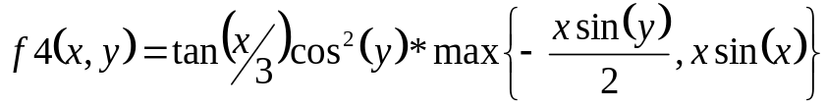,
Use following function heading:
public static double f4(double x, double y)

Test data: f4(2.5, 4.7) returns 0.00025277

The correct call to the static method is of the form: FunctionsGoneWild2013.f4(x, y)

5. Implement the following function
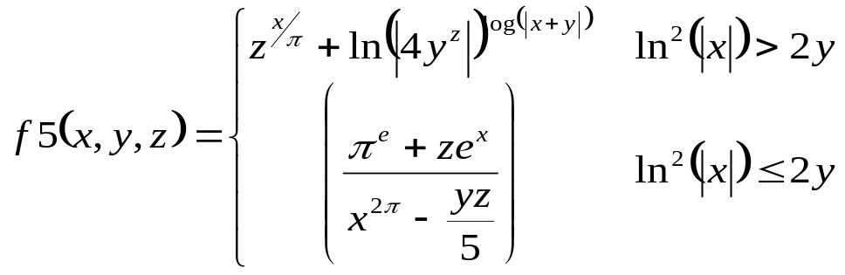
Use following function heading:
public static double f5(double x, double y, double z)

Test data: f5(π, 2.5, 3.3) returns 0. 0745626

The correct call to the static method is of the form: FunctionsGoneWild2013.f5(x, y, z)

6. Implement the following function
Consider the mathematical notation 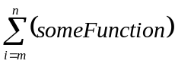 used to represent the summation of many similar terms. The notation 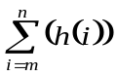 is defined as:
The subscript gives the symbol for an index variable, i. Here, i represents the index of summation; m is the lower bound of summation, and n is the upper bound of summation. In this case, i = m under the summation symbol means that the index i starts out equal to m. Successive values of i are found by adding 1 to the previous value of i, stopping when i = n. An example: 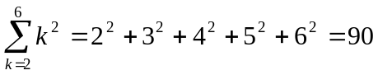.

Your task in this problem is to implement the following function.
Special note – all calculations are to be completed using integer math

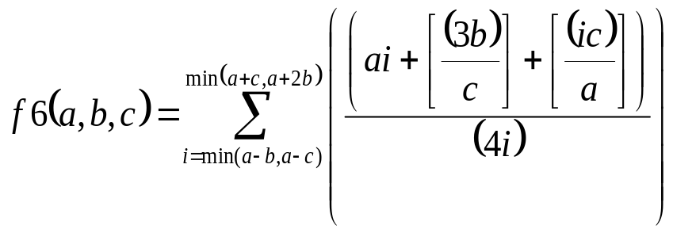 =
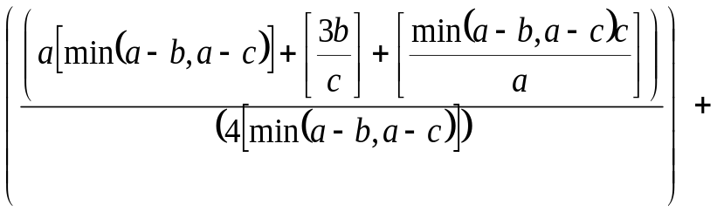
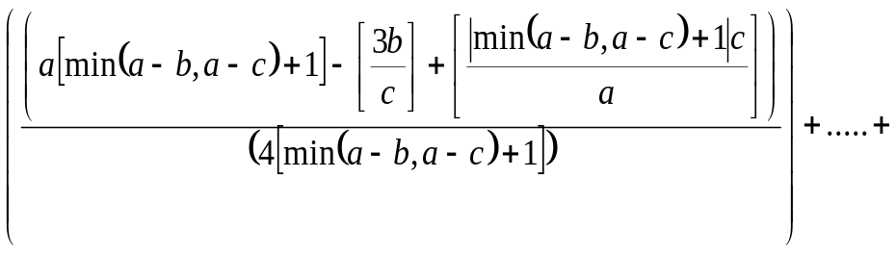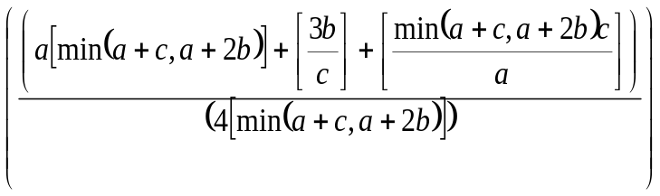
using the following function heading: public static int f6(int a, int b, int c)

Special Note: return 0.

Test data: f6(4, 2, 1) returns f(2) + f(3) + f(4) + f(5) = 1+1+1+1 = 4

The correct call to the static method is of the form: FunctionsGoneWild2013.f6(a, b, c)

7. Implement the following function
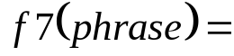Return the sum of all letters which have the appearance of numbers.

Letter | Number
O (Upper case only) | 0
I (Upper case only),  l (Lower case only) | 1
Z (Upper case only) | 2
E (Upper case only) | 3
h (lower case only) | 4
S (Upper case only) | 5
g (lower case only) | 6
L (upper case only) | 7
B (Upper case only) | 8
G (Upper case only) | 9

Yes, the above table is case sensitive.

Use following function heading:
public static int f7(String phrase)

Special Note: phrase.length() >= 0.

f7 Test data
f7(“IS”) return 1+5=6
f7(“GOAL”) return 9+0+7 = 16
f7(“ZEhG”) return 2+3+4+9 = 18
f7(“lEgS”) return 1+3+6+5 = 15
f7(“O NO”) return 0+0 = 0
f7(“He said”) return 0
f7(“lEgS have ZelGi”) return 1+3+6+5+4+2+1+9 = 31

8. Implement the following function
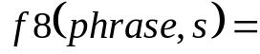 Return the number of time s.substring(1, 2) appears in phrase after s.substring(0, 1).

For example, 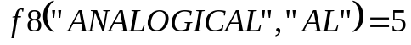 since there are two Ls (“AL”.substring(1,2)) after the first A (“AL”.substring(0,1)) in “ANALOGICAL”, and there are two Ls after the second A in “ANALOGICAL” , and there is one L after the third A in “ANALOGICAL”.

Use following function heading:
public static String f8(String phrase, String s)

Special Note: phrase.length() >= 0
str.length() == 2.
And phrase and str will only contain Upper case letter or spaces

f8 Test data
f8(“ANALOGIAL”, “AL”) return 1
f8(“GOAL”, “GA”) return 1
f8(“PEPPER”, “PE”) return 4
f8(“MISSISSIPPI”, “SI”) return 10
f8(“MISSISSIPPI”, “IS”) return 6
f8(“ASSESSORESSES”, “ES”) return 9
f8(“ASSESSORESSES”, “SE”) return 12
f8(“GOOGLE”, “MG”) return 0
and
f8(“HUMUHUMUNUKUNUKUAPUAA”, “UK”) return 12

9. Implement the following function
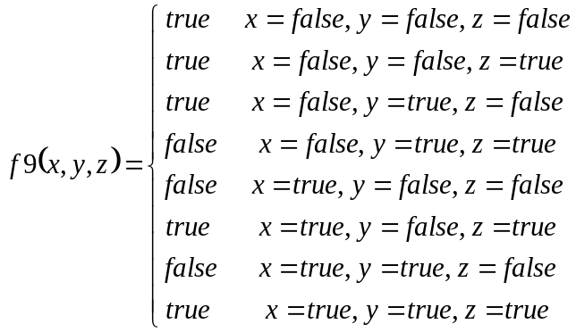
Use following function heading:
public static boolean f9(boolean x, boolean y, boolean z)

Test data: f9(false, false, false) returns true

10. Implement the following function
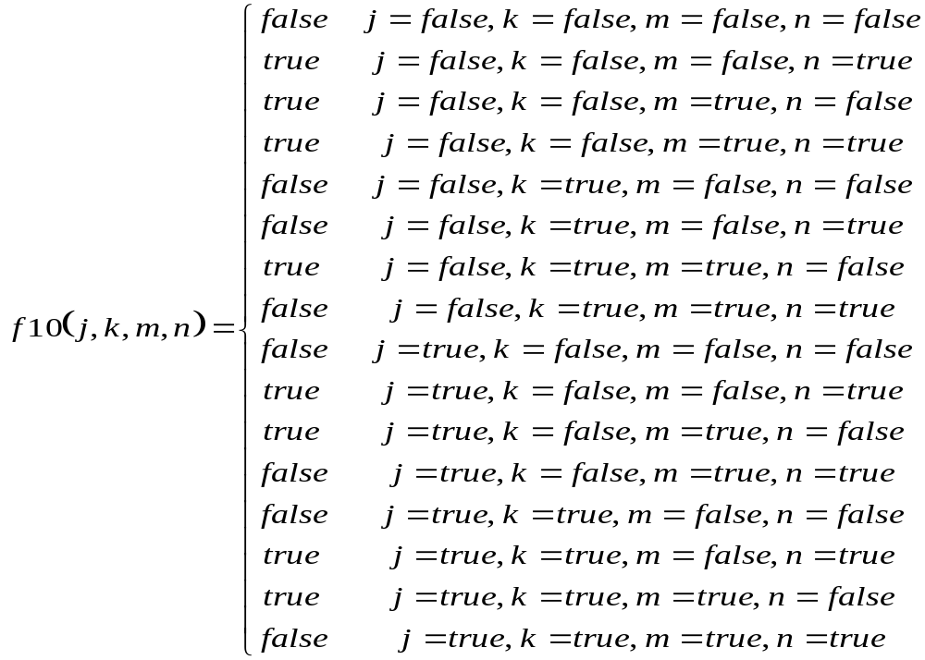
Use following function heading:
public static boolean f10(boolean j, boolean k, boolean m, boolean n)

Test data: f10(false, false, false, false) returns false

Each of the above functions is tested individually. Each function that is correctly implemented will earn one point. Additional bonus point for correctly implementing all groups of functions correctly as described in the first paragraph will be awarded! A total of 16 points are available.

